Reply Form to the Call for Evidence

Position limits and position management in commodity derivatives

Responding to this paper
ESMA invites comments on all matters in this paper and in particular on the specific questions summarised in Annex 1. Comments are most helpful if they:
- respond to the question stated;
- indicate the specific question to which the comment relates;
- contain a clear rationale; and
- describe any alternatives ESMA should consider.
ESMA will consider all comments received by 5 July 2019.
All contributions should be submitted online at www.esma.europa.eu under the heading ‘Your input - Consultations’. Please follow the instructions given in the document ‘Reply form for the call for evidence on position limits and position management controls in commodity derivatives’ also published on the ESMA website.
Instructions
In order to facilitate analysis of responses to the Call for Evidence, respondents are requested to follow the below steps when preparing and submitting their response:
      - Insert your responses to the questions in the Call for Evidence in the present response form.
      - Please do not remove tags of the type <ESMA_QUESTION_PLPM_1>. Your response to each question has to be framed by the two tags corresponding to the question.
      - If you do not wish to respond to a given question, please do not delete it but simply leave the text “TYPE YOUR TEXT HERE” between the tags.
      - When you have drafted your response, name your response form according to the following convention: ESMA_PLPM_nameofrespondent_RESPONSEFORM. For example, for a respondent named ABCD, the response form would be entitled ESMA_PLPM_ABCD_RESPONSEFORM.
      - Upload the form containing your responses, in Word format, to ESMA’s website (www.esma.europa.eu under the heading “Your input – Open consultations” “Call for Evidence on Position limits and position management in commodities derivatives”).

Publication of responses
All contributions received will be published following the close of the consultation, unless you request otherwise. Please clearly and prominently indicate in your submission any part you do not wish to be publicly disclosed. A standard confidentiality statement in an email message will not be treated as a request for non-disclosure. A confidential response may be requested from us in accordance with ESMA’s rules on access to documents. We may consult you if we receive such a request. Any decision we make not to disclose the response is reviewable by ESMA’s Board of Appeal and the European Ombudsman.
Data protection
Information on data protection can be found at www.esma.europa.eu under the heading Legal Notice.
Who should read this paper
All interested stakeholders are invited to respond to this consultation paper. This consultation paper is primarily of interest to trading venues, investment firms and non-financial counterparties trading in commodity derivatives, but responses are also sought from any other market participant including trade associations, industry bodies and investors.

General information about respondent
Name of the company / organisation | Europex
Activity | Regulated markets/Exchanges/Trading Systems
Are you representing an association? | ☒
Country/Region | Belgium

Introduction
Please make your introductory comments below, if any
<ESMA_COMMENT_PLPM_1>
Europex, the Association of European Energy Exchanges, welcomes the opportunity to contribute to the ESMA call for evidence on position limits and position management in commodity derivatives. Europex has actively participated in previous public consultations on the MiFID II/MiFIR package, including on the position limit regime as well as on its implementing legislation and the related regulatory guidance. The present call for evidence offers an important opportunity to review the regime 18 months after its entry into application.
Importantly, Europex supports the policy objectives of MiFID II/MiFIR to ensure transparency and prevent abuse in commodities markets. At the same time, certain key aspects of the position limit regime remain a challenge and need to be addressed urgently in order to prevent adverse negative consequences to the integrity and competitiveness of European commodity derivatives markets. The most important aspect concerns the position limits for new, illiquid and less liquid contracts. (For a number of well-developed benchmark contracts the MiFID II position limit regime has so far been able to function reasonably.) For the development of new products and further growth in existing illiquid commodity derivatives markets, the regime has proven to be a substantial barrier. Fast growing markets in particular have suffered from an increasingly restrictive limit as open interest increases, an inflexible treatment in terms of their categorisation under the position limit framework and an inaccurate reflection of the underlying physical markets.

Furthermore, Europex believes that the regime may contribute to pushing the liquidity to the exchange with the highest liquidity, if a materially different position limit applies to a similar contract listed by one or several different exchanges.

Against this background and based on the general need to make the position limit regime more proportionate and efficient, Europex sees merits in limiting the application of the MiFID II position limit regime to a more limited set of important critical (benchmark) commodity derivative contracts. Such a refocus of the position limit regime on benchmark contracts would make it more efficient, mitigate the unintended consequences and reduce the compliance burden for all concerned parties (market participants, trading venues and NCAs/ESMA). Most importantly, such a targeted approach would allow new and nascent products to develop in line with the policy objective of MiFID II as stipulated in RTS 21:

“Position limits should not create barriers to the development of new commodity derivatives and should not prevent less liquid sections of the commodity derivative markets from working adequately“

In addition, Europex believes that an amended regime would better fulfil the overall policy objective of MiFID II to “improve the functioning and transparency of commodity markets and address excessive commodity price volatility”. A refocus of the regime is justified as the price formation mainly occurs in benchmark products. New and nascent products constitute a minor share of commodity markets. Such contracts are unlikely to influence price movements in the underlying physical commodity markets and thus do not negatively impact consumers. Moreover, in order to prevent market squeezes, it would be sufficient to set limits for the period right before expiry rather than covering the entire maturity curve. Finally, limiting the scope of the EU position limit regime would bring us closer to a regulatory level-playing field between the EU and the U.S. and enable liquid and competitive EU commodity markets.

The other (non-significant) contracts would remain subject to the position reporting regime under MiFID II Article 58, the pre-existing position monitoring and position management measures by exchanges and the market oversight practices of the exchanges’ market supervision and market surveillance departments that apply the principles set out in the Regulation on Energy Markets Integrity and Transparency (REMIT) and the Market Abuse Regulation (MAR). Thus, removing position limits for such contracts would not pose any risk to the transparency and integrity of the respective markets. On the contrary, attracting more volume to regulated venues would contribute to a more transparent trading environment.

Europex further commits to making an assessment of the key criteria to be taken into account when determining that a contract should be classified as a benchmark contract to be in scope of the MiFID II position limit regime, in the second half of this year.

<ESMA_COMMENT_PLPM_1>

Questions

- : In your view, what impact, if any, did the introduction of position limits have on the availability and liquidity of commodity derivative markets? What are in your views the main factors driving this development, e.g. the mere existence of a position limit and position reporting regime, some specific characteristics of the position limit regime or the level at which position limits are set? Please elaborate by differentiating per commodity asset class or contract where relevant and provide evidence to support your assessment.
<ESMA_QUESTION_PLPM_1>
Europex believes that the MiFID II position limit regime has so far been able to function for a number of well-developed benchmark contracts. These highly developed markets are characterised by a large number of different types of active trading firms and an overall substantial amount of open interest.

However, for the development of new products and further growth in existing illiquid commodity derivatives markets the position limit regime has proven to be a substantial barrier. Fast growing markets in particular have suffered from (1) an increasingly restrictive limit as open interest increases, (2) inflexible treatment in terms of their categorisation under the position limit framework and (3) an inaccurate reflection of the underlying physical markets.

Moreover, there is also room for improvement for the functioning of the position limit regime in liquid markets.

  - Challenges for fast growing markets

- Increasingly restrictive standardised limit
Contracts classified as ‘illiquid’ under the current MiFID II position limit framework receive a standardised limit of 2,500 lots. They thereby effectively obtain a highly restrictive limit (resembling a baseline limit of 25 percent of open interest) when open interest increases close to 10,000 lots. In consequence, market participants are forced to decrease their positions and the open interest returns to a lower level, thereby sealing the illiquid status of the product.
And whilst in theory in line with the ESMA Q&As on ‘commodity derivative topics’, National Competent Authorities (NCAs) can use different derogations for illiquid markets which have an open interest between 5,000 and 10,000 lots. However, these remain difficult to apply in practice and are often not sufficient to mitigate the negative impact of disproportionately low position limits.
Any increase of the limit under the available derogation will need to be substantial in order to provide sufficient relief to market participants close to the limits and prevent restricting trading activity in fast growing markets. By way of example, an increase of a given position limit with 500 lots will only have a very limited impact, effectively allowing market participants close to the limit to trade additional lots equivalent of four Calendar Year or eight Season contracts. Additionally, NCAs tend to reserve the use of the derogation for cases for which the exchanges can bring forward other arguments than the fact that the contract is illiquid and needs room to grow, while this is one of the most critical arguments that apply to all contracts coming close to 10,000 lots.
Once the limit is reached, participants withdraw from the market, often switching to another trading venue outside the MiFID II regime, thereby leaving the regulator no time to adjust the limit upwards.
Furthermore, in relation to newly launched contracts, it is not unusual that only one participant sits on the buy- or sell-side of the market. In such cases, even a fifty percent limit is not sufficient to allow the market to mature.

- Inflexible categorisation of markets and recalibration of position limits

In order to provide for a workable regime for growth markets, and given that the NCAs cannot set position limits on the basis of anticipated open interest growth, NCAs need to be able to process near instant updates to the categorisation of markets and readjust the applicable limits as open interests in a market increases. This is especially true for markets that experience strong increases in open interest in a short period of time. Markets with initially relatively low levels of open interest can develop into liquid markets in a matter of weeks or months. In order for a limit not to impede the development of fast growing markets the following aspects should be taken into consideration:
- The growth of open interest requires a timely reclassification of a market under the position limit regime (for example from ‘illiquid’ to ‘less liquid’) in order to allow the position limit to be adjusted to a workable level and before it becomes unnecessarily restrictive. The use of administrative acts to implement or adapt position limits, as required by national legislation in some Member States, is an example of how inflexible requirements can hamper the ability of NCAs to adapt to the pace of fast growing markets.

- It is essential that NCAs take an adequate approach with regard to the time period they take as a basis to calculate open interest for the purpose of setting a position limit and classifying a market. Not looking at the right time period could result in relatively frequent requests to NCAs for adjustments of the limit, as the newly set limit could be reached with only a small amount of transactions in a fast-growing market.

- In certain cases, such as the transition to a new benchmark contract, it would be desirable to enable NCAs to categorise markets and set limits based on anticipated growth in open interest. One example for this is the EEX Supramax Freight Future, for which there is a process in the market to update the existing index methodology from Supramax-6TC (STCM) to Supramax-10TC (SPTM). The process of transferring to a new index means that the market will switch trading over time from one product to the other. At the point in time where the market participants have switched over to the new index, they typically also want to transfer positions in the old to the new contract as this enables them to actively manage their open positions in a single contract. Without this transfer, positions in the old contract become 'stranded' and members are forced to hold them until expiry, as finding a counterparty prepared to trade the old contract becomes very difficult. However, this is currently prevented by the fact that the de minimis limit for the new contract is not sufficiently high to allow market participants to transfer their old position to the new contract. As a consequence, EEX becomes locked into a scenario where an action that would enable a position limit increase cannot be conducted as it would initially result in some members breaching limits. For these particular cases, the NCAs should be entitled to base the position limit of the new contract on the open interest of the old contract.

In practice it has proven to be impossible for NCAs to reclassify markets and recalibrate the applicable limits quickly enough and in a manner that would prevent a negative impact on the development of fast growing markets. Figure 1 illustrates this negative impact on one of ICE’s previously fast growing markets when subjected to the MiFID II position limit regime. The material growth in open interest (area marked in yellow) started in Q4 2017, but this momentum was severely impaired at the end of 2017 and in early 2018 in anticipation of the introduction of the MiFID II position limit regime. Before any reclassification of this market and subsequent recalibration of the limit could occur, the damage caused to the development of this market had proven to be irrevocable. This negative effect on the development of commodity derivatives markets described above is stereotypical for fast growing markets subject to the MiFID II position limit regime.
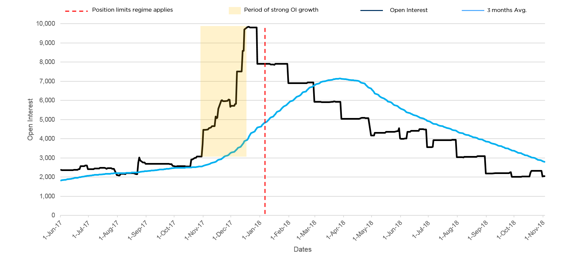
Figure 1: Impact of position limit regime on development of ICE Endex Italian PSV Gas Futures market.
Figures 2 and 3 illustrate this negative impact on PEGAS Czech Virtual Trading Point (CZ VTP) and PEGAS Zeebrugge Trading Point (ZTP) gas future markets. Both markets took off in the course of 2018, but then declined once the 2,500 lots limit had become too restrictive. With only 10 to 12 market participants registered to trading and only 1 or 2 very active market participants being responsible for most of the volumes – an absolutely normal situation for a new contract -, the position limit put a halt to the further development of the contract. While some participants are eligible for the hedging exemption (and applied for one), some important participants are investment firms and cannot benefit from this exemption, meaning that they have no other option than to stop trading and to look for other hedging alternatives.

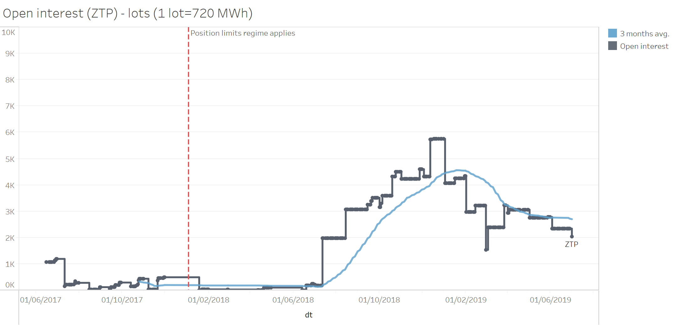
Figure 2: Impact of position limit regime on development of PEGAS ZTP gas futures market.
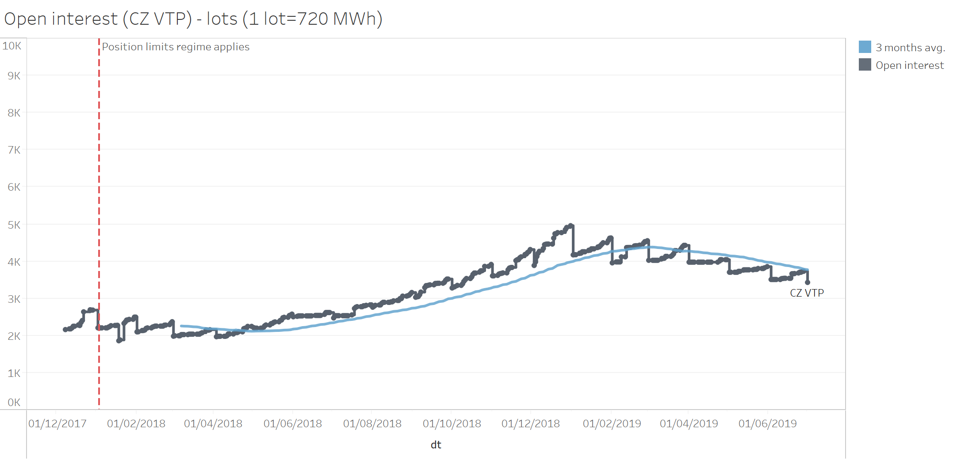
Figure 3: Impact of position limit regime on development of PEGAS Czech VTP gas futures market.

3) Inaccurate reflection of the underlying physical markets
For some commodity derivatives, the characteristic of the underlying physical market is such that an effective hedge can only be achieved by trading a specific number of lots. Such a number cannot be traded without exceeding the given position limit. This is not only an obstacle to the hedging company, as it will have to obtain a hedging exemption, but even more to the counterparty of the hedge, which might be a financial entity that is not eligible to the hedging exemption. Yet, under the current MiFID II provisions, the limit cannot be raised based on anticipated growth in open interest.
As a first example, the recently launched ICE Futures Europe TD20 West Africa to UK-Continent (Baltic) Future has grown significantly over the past few months, reaching over 6,000 lots of open interest. The contract is a Suezmax crude route, West Africa to UK Continent for tankers sized on average 130,000 MT (DWT). The biggest positions exceeding 1,900 lots are held by commodity traders, some of which are located outside the EU and do not hold hedging exemptions. Companies with Suezmax type tanker fleets tend to hedge calendar years forward with fleet sizes of up to 20 tankers and above.
To hedge a fleet of ten tankers on a year-forward basis - the trade size will be (either as a single trade or done in a sequence of multiple smaller trades for the same Calendar Year tenor, keeping positions open throughout expiry):
130 lots * 12 months * 10 tankers = 15,600 lots to hedge freight rates exposure for a single Calendar year (i.e. a Cal 2019 trade)
With fast growing trading volumes in wet freight, companies are now extending hedges down the curve, trading to cover Cal19 / Cal20 and even Cal21 tenors - which can be observed on the VLCC TD3C route (Arab Gulf to China crude route). A new regulation by the International Maritime Organisation going live in 2020 (IMO 2020) has been a significant factor behind the longer-dated hedges as companies are seeking certainty and stability of “locked-in” freight levels that are expected to become volatile as new sulphur caps for bunker fuel will start affecting the cost of shipping from January 2020.
Traders active in TD20 have indicated the business need to hedge multiple calendar years forward in TD20 route contracts. This would effectively result in tripling trading volumes in the above traded volume calculation scenario, with potential volumes amounting to 46,800 lots.
However, the growth of the contract is restricted by the current de minimis position limit. Further development of this contract requires dynamic changes of the current limit from a fixed 2,500 lots level to a much higher limit based on the open interest.
The second example is the EEX Capesize 5TC Dry Freight Future, which is currently in excess of 6,000 lots open interest at ECC, and, hence, has a position limit of 2,500 lots. One contract reflects the value of a single day’s hire for a Capesize dry bulk carrier which are predominately used for transporting iron ore and coal.
Trading several years forward is a common practice in the freight market, particularly at the current time when the market expects significant increases in price volatility linked to the implementation of IMO 2020.
Should a vessel owner or operator wish to hedge forward to lock in rates now to reduce their exposure to this market change, they could reasonably be expected to trade the remaining period of Calendar 2019, all of Calendar 2020 and possibly also Calendar 2021. Such a trade would represent a strip between 21 and 33 months. In addition, given that the vessel owner or operator would want to completely cover their risk, it would need to hedge 30 days per month.
An owner with a relatively small fleet of ships, e.g. 5 vessels, would not be able to do so, as even hedging just the remaining period of Calendar 2019 and all of Calendar 2020 would make them exceed the de minimis position limit of 2,500 lots:
April 19 + Cal 20 = 21 months x 30 days per month x 5 vessels = 3,150 lots
April 19 + Cal 20 + Cal 21 = 33 months x 30 days per month x 5 vessels = 4,950 lots
Larger vessel owners or operators, or those wishing to hedge further ahead (transactions covering 5 years forward are not unusual), as well as their counterparties, are even more greatly impacted by the given limits. Moreover, it has to be kept in mind that these markets are highly global with competing exchanges outside of Europe offering almost identical contracts that are not subject to position limits or have a hedging exemption available for financial counterparties.
In sum, the further development of this contract requires dynamic changes of the current limit to a significantly higher limit based on anticipated open interest.

  - Challenges for fast growing markets

Electricity and gas derivatives markets play an important role in the further integration of the EU Internal Energy Market by allowing European energy trading companies to hedge their risks across borders while maximising the social welfare benefits of an integrated energy market for consumers. They are subject to a tailor-made regulatory regime, i.e. REMIT, MAR, MiFID and EMIR, all aimed at preventing market abuse and ensuring the integrity and transparency of the market. An increasing level of integration of electricity and gas markets has been observed across Europe over the past 20+ years, with multiple liquidity pools emerging in some underlying deliverables such as German Power and Dutch Gas. It is important that these liquidity pools are allowed to develop in accordance with the genuine economic needs of the market and its participants, rather than as a result of financial regulation.
In this context, Europex notes that, since the beginning of the application of the position limit regime, developing liquidity in some of these pools has proven more difficult than on venues with a high open interest in the concerned contract. This is often due to much higher position limits available in ‘other months’ for already liquid contracts than for contracts in other, smaller liquidity pools.
When position limits are materially different, there is a risk that traders and market makers will only trade on the most liquid market, where they have a lower risk of breaching the position limit. This may prevent the development of liquidity on less liquid venues, thereby reducing options available to market participants to manage their risks against volatile spot prices other than on the exchange on which the most liquid contract is traded. Comparing the German power contract listed by Nasdaq and the German power contract listed by EEX, for example, the latter is substantially more liquid as the open interest in the contract is substantially higher. It may therefore be that the regime contributes to pushing the liquidity to the largest exchange hosting the most liquid contract, effectively preventing liquidity from being built up elsewhere. Thus, the moment may have come to analyse the role of the position limit regime in supporting the further development of liquid electricity and gas markets across Europe. Especially, given that the tailor-made Regulation on Wholesale Energy Market Integrity and Transparency (REMIT) as well as the Market Abuse Regulation (MAR) have been put in place to prevent possible market abuse in these markets.
<ESMA_QUESTION_PLPM_1>

- : Have you identified other structural changes in commodity derivative markets or in the underlying markets since the introduction of the MiFID II position limit regime, such as changes in market participants? If so, please provide examples, and where available data, and differentiate per commodity derivative asset class where relevant.
<ESMA_QUESTION_PLPM_2>
The Exchanges have observed an increased difficulty for financial counterparties such as investment banks or commodity trading houses to efficiently serve their clients in commodity markets (e.g. oil refineries, cocoa producers, etc). This has been caused by the inability of those counterparties to hedge risks through structurally more complex transactions than simply trading on a client’s account.

Indeed, the position limit regime includes exemptions for market participants pursuing hedging activities. However, the MiFID II definition of hedging as set out in RTS 20 is clear that only non-financial entities can engage in such activities, thereby rendering the exemption unviable to investment banks or commodity trading houses which both play a vital role in providing smaller commercial players with access to commodity derivatives markets. Therefore, the hedging exemption cannot be considered a universal solution to the inappropriately designed pre-trade transparency rules or the disproportionate position limit regime.

An example of such a situation is the so called Refining Margin Hedge, often used in oil markets, whereby an investment bank agrees with its client, a refiner, on a single price of a basket comprising various refined products. Once the refiner agrees the single price for the basket, the bank executes the offsetting trades in the futures market on its own account.

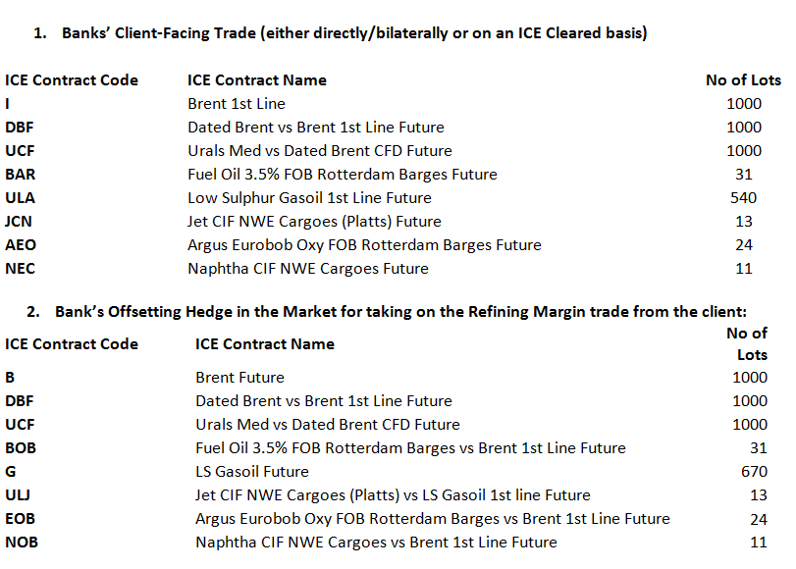

Even though within the context of such a transaction the bank clearly performs a hedging activity, it would not be able to make use of the exemption envisaged under MiFIR Article 8 or MiFID Article 57.

As a second example, in iron ore and freight it is possible and sometimes common that a bank would finance a miner or steel mill with the caveat that the business needs to initiate a hedging programme to remove volatility from future costs or revenues (or both). The hedging programme would usually be conducted with the bank on an OTC basis with the bank then offsetting that risk in the cleared market.

Again, even though within the context of such transaction the bank clearly performs a hedging activity, it would not be able to make use of the exemption envisaged under MiFIR Article 8 or MiFID Article 57.

Furthermore, some Europex members have observed growth in bilateral trading since the introduction of the MiFID II position limit regime. This has partly been driven by the perception that bilateral trading is cheaper and less burdensome from a regulatory perspective, including being out of scope of the position limit regime. Europex would therefore caution against any regulatory requirement which pushes more liquidity onto bilateral markets as the latter are excluded from the principles of independent price validation, post-trade publication, oversight and central clearing, thereby reducing market transparency and increasing systemic risk.
<ESMA_QUESTION_PLPM_2>

- : Do you consider that position limits contribute to the prevention of market abuse in commodity derivatives markets? Please elaborate by differentiating per conduct, per commodity asset classes or contract where relevant and provide evidence to support your assessment when available.
<ESMA_QUESTION_PLPM_3>
We do not believe the regime has had a significant impact on the prevention of market abuse in energy derivatives markets. This is mainly because of three reasons.

      - Pre-existing position management regime: Europex members have considerable experience in operating position management systems. Exchanges have developed a comprehensive, risk-based regime based on position, delivery and expiry limits with regards to commodity derivatives traded on their markets. At the same time, the position management regimes operated by exchanges are proportionate and efficient. They focus on a limited number of benchmark contracts and the time period right before expiry rather than on the entire maturity curve. The regime has contributed to preventing market abuse and excessive speculation which could negatively impact global retail prices. However, it has also allowed new and nascent products to develop.

      - Pre-existing regulation: Besides being subject to position management regimes, exchange-traded gas and power derivatives markets are also under close scrutiny of the exchanges’ market supervision and market surveillance departments. The departments apply the principles set out in the Regulation on Wholesale Energy Markets Integrity and Transparency (REMIT) and the Market Abuse Regulation (MAR), which both apply to gas and power derivatives markets. While REMIT introduces a sector-s​pecific legal framework for identifying and penalising insider trading and market manipulation in wholesale energy markets across Europe, MAR establishes a pan-European regime to prevent and detect market abuse, market manipulation and insider dealing in financial markets, including in energy derivatives markets. These pre-existing regulations as well as the work of market supervision and market surveillance departments have been effective in preventing market abuse and excessive speculation. In this context, it is important to highlight that in order to identify and prevent market abuse MAR monitors trading behaviour in combination with position size, while the MiFID II position limit regime only monitors position size.

      - The nature of most gas and power derivatives contracts and the underlying market:

  - Both gas and power are grid-bound commodities, meaning that market participants have no control over the actual destination of the produced energy. In addition, electricity can only be stored to a very limited extent. And since the liberalisation of the European Internal Energy Market (IEM) and in the context of the energy transition, these markets have become highly diversified.

  - Last but not least, most European gas and power derivatives contracts are financially-settled. This means that in order to corner or squeeze the market, one has to be able to manipulate the underlying reference price or index. As gas and power indices in Europe are sufficiently robust, market squeezes are very unlikely to occur.
<ESMA_QUESTION_PLPM_3>

- : In your view, what impact do position limits have on the orderly pricing and orderly settlement of commodity derivative contracts? Please elaborate by differentiating per asset class or per contract where relevant and provide evidence to support your answer when available.
<ESMA_QUESTION_PLPM_4>
Europex believes that a properly calibrated position management regime can play an important role in ensuring orderly pricing and settlement of commodity derivatives contracts. However, Europex does not consider the current MiFID II position limit regime to have contributed to achieving these objectives. Rather, they have been met by the exchanges’ pre-existing position management regimes as well as their efficient market oversight systems (including compliance, supervision and surveillance).
<ESMA_QUESTION_PLPM_4>

- : More generally, and beyond the specific items identified above, what would be your overall assessment of the impact of position limits on EU commodity derivatives markets since the application of MiFID II?
<ESMA_QUESTION_PLPM_5>
The MiFID II position limit regime has so far been able to function for a number of well-developed liquid contracts. These highly developed markets are characterised by a large number of different types of active trading firms and an overall substantial amount of open interest. However, for the development of new products and further growth in existing illiquid commodity derivatives markets, the position limit regime has proven to be a substantial barrier. Fast growing markets in particular have suffered from (1) an increasingly restrictive limit as open interest increases and (2) an inflexible treatment in terms of their categorisation under the position limit framework and (3) an inaccurate reflection of the underlying physical markets.

See our response to Q1 for more details.

In order to remedy these issues and to move to a more proportionate and efficient position limit regime, Europex agrees with ESMA’s view that there “could be merits in limiting the application of MiFID II position limits to a more limited set of important, critical (benchmark) commodity derivative contracts”. Such a refocus of the position limit regime on benchmark contracts would make it more efficient, mitigate the unintended consequences and reduce the compliance burden for all concerned parties (market participants, trading venues as well as NCAs/ESMA). Most importantly, such an approach would prevent market abuse and excessive speculation which may negatively impact global retail prices, while allowing new and nascent products to develop. This would be in line with the policy objective of MiFID II as stipulated in RTS 21:

“Position limits should not create barriers to the development of new commodity derivatives and should not prevent less liquid sections of the commodity derivative markets from working adequately“

At the same time, Europex believes that an amended regime would better fulfil the overall policy objective of MiFID II to “improve the functioning and transparency of commodity markets and address excessive commodity price volatility”. A refocus of the systems is justified as the price formation mainly occurs in benchmark products. New and nascent products constitute a minor share of commodity markets. Such contracts are unlikely to influence price movements in the underlying physical commodity markets and thus do not negatively impact consumers. Moreover, in order to prevent market squeezes, it would be sufficient to set limits for the period right before expiry rather than covering the entire maturity curve. Finally, limiting the scope of the position limit regime would bring us closer to regulatory level-playing field between the EU and US commodity markets and protect the liquidity and competitiveness of EU commodity markets.

The other (non-significant) contracts would remain subject to the position reporting regime under MiFID II Art. 58, the pre-existing position monitoring and position management measures by exchanges and the market oversight practices of the exchanges’ market supervision and market surveillance departments that apply the principles set out in the Regulation on Energy Markets Integrity and Transparency (REMIT) and the Market Abuse Regulation (MAR). Thus, removing the position limits for such contracts would not pose any risk to the transparency and functioning of the respective markets. On the contrary, attracting more volume to regulated venues would contribute to a more transparent trading environment.

However, should such a refocus not be possible, then RTS 21 should suspend the application of the spot and other months position limit for commodity derivatives traded on a trading venue with a total combined open interest in spot and other months contracts not exceeding 20,000 lots over a consecutive three-month period (where this assessment must take place over the total period, and not on a Day 1/single day basis).

Europex further commits to making an assessment of the key criteria to be taken into account when determining that a contract should be classified as a benchmark contract to be in scope of the MiFID II position limit regime, in the second half of this year.
<ESMA_QUESTION_PLPM_5>

- : Do you consider that position management controls have an impact on the liquidity of commodity derivatives markets? If so, please elaborate, differentiating per commodity derivative trading venues or contract where appropriate.
<ESMA_QUESTION_PLPM_6>
Please see our response to Q1.
<ESMA_QUESTION_PLPM_6>

- : Do you consider that position management controls adopted by commodity derivative trading venues have a role on the prevention of market abuse? If so, please elaborate, differentiating per commodity derivative trading venues or contract where appropriate.
<ESMA_QUESTION_PLPM_7>
As indicated in the description of position management controls published on the ESMA website, Europex members have operated comprehensive position management regimes for many years, thereby ensuring compliance with their rulebooks and meeting all regulatory requirements.

Europex members believe that their pre-MiFID II position management regimes along with their market supervision and surveillance systems have contributed substantially and efficiently to preventing market abuse and ensuring orderly trading and settlement in exchange-traded commodity markets.
<ESMA_QUESTION_PLPM_7>

- : Do you consider that position management controls adopted by commodity derivative trading venues have a role on orderly pricing and settlement conditions? If so, please elaborate, differentiating per commodity derivative trading venues or contract where appropriate.
<ESMA_QUESTION_PLPM_8>
As indicated in the description of position management controls published on the ESMA website, Europex members have operated comprehensive position management regimes for many years, thereby ensuring compliance with their rulebooks and meeting all regulatory requirements.

Europex members believe that their pre-MiFID II position management regimes, along with their market supervision and surveillance systems, have contributed substantially and efficiently to preventing market abuse and ensuring orderly trading and settlement in exchange-traded commodity markets.
<ESMA_QUESTION_PLPM_8>

- : If you are a commodity derivative trading venue, please explain how you have been exercising your position management controls since MiFID II application. In particular, how frequently did you ask further information on the size or purpose of a position, on beneficial owners or assets and liabilities in the underlying commodity under Article 57(1)(b) of MiFID II, require a person to terminate or reduce a position under Article 57(1)(c) of MiFID II, require a person to provide liquidity back into the market under Article 57(1)(d) of MiFID II or exercise any of your additional position management controls?
<ESMA_QUESTION_PLPM_9>
TYPE YOUR TEXT HERE
<ESMA_QUESTION_PLPM_9>

- : Do you have any general comment on the position limit regime and associated position reporting introduced by MiFID II?
<ESMA_QUESTION_PLPM_10>
See response to Q5.
<ESMA_QUESTION_PLPM_10>

- : In your view, how will EU commodity derivatives markets be impacted by the UK leaving the EU? What consequences do you expect from Brexit on the commodity derivatives regime under MiFID II?
<ESMA_QUESTION_PLPM_11>
TYPE YOUR TEXT HERE
<ESMA_QUESTION_PLPM_11>

- : Taking into consideration the intended purposes of position limits, do you consider that they deliver the same benefit across all commodity asset classes and across all types of commodity derivatives? Please explain.
<ESMA_QUESTION_PLPM_12>
Referring to our responses to Q3 and Q4, Europex believes that there have been limited benefits of the EU position limit regime for gas and power markets. This is because the objectives of preventing market abuse and contributing to orderly pricing and orderly settlement are already achieved by the exchanges’ pre-existing position management regime as well as their market oversight systems (including compliance, supervision and surveillance) that are performed in accordance with REMIT and MAR.
<ESMA_QUESTION_PLPM_12>

- : Would you see benefits in limiting the application of position limits to a more limited set of commodity derivatives? If so, to which ones and on which criteria?
<ESMA_QUESTION_PLPM_13>
Yes. Please see our response to Q5. Europex has always supported the view that a proportionate and efficient position limit regime should focus on a limited number of benchmark contracts which are crucial to the orderly functioning of their respective commodity markets. This is because price formation mainly occurs in such benchmark products. Other commodity derivatives contracts follow the benchmark contracts in terms of price formation and thus should not be subject to limits. Also, many of the basis markets trade as spreads to the benchmark contract. In such cases, position limits for basis markets potentially restrict the usage of spread strategies as market participants can only execute the benchmark leg without breaching the limits.

At the same time, it is important to emphasise that energy exchanges already have sophisticated systems and controls in place to achieve the policy objectives of MiFID II, i.e. ensuring orderly pricing and settlement and preventing market abuse.

Europex further commits to making an assessment of the key criteria to be taken into account when determining that a contract should be classified as a benchmark contract to be in scope of the MiFID II position limit regime, in the second half of this year.
<ESMA_QUESTION_PLPM_13>

- : More specifically, are you facing any issue with the application of position limits to securitised derivatives? If so, please elaborate.
<ESMA_QUESTION_PLPM_14>
TYPE YOUR TEXT HERE
<ESMA_QUESTION_PLPM_14>

- : Do you consider that there would be merits in reviewing the definition of EEOTC contracts? If so, please explain the changes you would suggest.
<ESMA_QUESTION_PLPM_15>
Europex is of the view that there are no grounds for a review of the EEOTC contracts definition. The Exchanges consider that the key objectives of introducing this concept into MiFID II have been the following: (i) to prevent a circumvention of the provisions by trading equivalent contracts in the OTC market, (ii) to allow for netting of equivalent contracts traded on venues and in the OTC markets. Both objectives have been achieved with the current definition.

Rather than extending the scope of the position limit regime (by broadening the definition of EEOTC and same contracts) and ensuring a level playing field between on-exchange and OTC trading, as well as between exchanges, we believe that the focus of the review should be on making the position limit regime more proportionate and efficient.
<ESMA_QUESTION_PLPM_15>

- : In your view, would there be a need to review the MiFID II position limit exemptions? If so, please elaborate and explain which changes would be desirable.
<ESMA_QUESTION_PLPM_16>
1. The hedging exemption

Yes. Whilst the position limit regime includes exemptions for market participants pursuing hedging activities, the MiFID II definition of hedging as set out in RTS 20 is clear that only non-financial entities can engage in such activities, thereby rendering the exemption unviable to investment banks or commodity trading houses which both play a vital role in providing smaller commercial players with access to commodity derivatives markets. Additionally, within some industrial energy groups, a MiFID II authorised investment firm may act as a market-facing entity for the whole group and manage the positions (including the risk-reducing ones) of non-financial group entities.

For this reason, the hedging exemption cannot be considered a universal solution to inappropriately designed pre-trade transparency regime or disproportionate position limits.
An example of a such situation is the so called Refining Margin Hedge, often used in oil markets, whereby an investment bank agrees with its client, a refiner, on a single price of a basket comprising various refined products. Once the refiner agrees the single price for the basket, the bank executes the offsetting trades in the futures market on its own account.
Even though within the context of such a transaction the bank clearly performs a hedging activity, it would not be able to make use of the exemption stipulated in MiFIR Article 8 or MiFID Article 57.

As a second example, in iron ore and freight, it is possible and sometimes common practice that a bank would finance a miner or steel mill with the caveat that the business needs to initiate a hedging programme to remove volatility from future costs or revenues (or both). The hedging programme would usually be conducted with the bank on an OTC basis with the bank then offsetting the risk in the cleared market. Again, even though within the context of such a transaction the bank clearly performs a hedging activity, it would not be able to make use of the exemption envisaged under MiFIR Article 8 or MiFID Article 57.

Europex members have extensive experience in operating position management systems based on hedging exemptions. Under this regime, they can grant such exemptions to any market participant, regardless of their legal status, provided that the hedging intention is adequately documented and demonstrated. This ensures that the genuine hedging activity is not restricted and allows commodity market participants to manage their risks efficiently.

Europex proposes that an analogous regime is introduced within the context of the MiFID II/MiFIR package.

- The liquidity provision exemption

Similar to this issue, and contrary to the general ancillary activity exemption regime in Article 2(4) of MiFID II, the position limit regime does not include a liquidity provision exemption. Such an exemption is particularly necessary for new contracts that need financial entities to incentivise trading in the contract, at least if the position limit regime continues to include the restrictive 2,500 lots limit on new and illiquid contracts. If no such exemption is available and the 2,500 lots limit continues to apply, exchanges will have to contract a “panel” of liquidity providers to ensure that none of these firms exceed their position limits. In nascent markets it is highly possible that there may not be the required number of counterparties to build such a ‘panel’ and even if this was the case, it adds significant costs for the exchange. In order to avoid such a situation, Europex recommends to include an exemption in the position limit regime based on the same conditions as the liquidity provision exemption outlined in Article 2(4) of MiFID II and the ESMA Q&A on MiFID II/MiFIR commodity derivatives topics. This liquidity provision exemption should be implemented similarly to the hedging exemption under the position limit regime.
<ESMA_QUESTION_PLPM_16>

- : Would you see merits in the approach described above and the additional flexibility provided to CAs for setting the spot month limit in cash settled contracts? Please explain.
<ESMA_QUESTION_PLPM_17>
Yes. Europex agrees that NCAs should have an optionality to set limits based on open interest for both spot and other months. Such a solution would prevent negative unintended consequences of the position limits regime for certain commodity derivative contracts which serve as pricing benchmarks and risk-management proxies in the absence of direct hedging instruments.

However, it is important to emphasise that setting limits for both spot and other months based on open interest should be an optionality and by no means a rule in setting position limits. It should be conditioned upon specific characteristics and functions of a commodity derivative contract in question. For example, in the case of freight, the ESMA MiFID II/MiFIR commodity derivatives topics Q&A granted flexibility to NCAs to set the spot month position limit based on open interest as deliverable supply was almost impossible to define.

Furthermore, it has to be noted that for power and gas the significant difference between deliverable supply and open interest can be explained by the fact that trading is still happening predominantly bilaterally and is taking place on different exchanges. It is therefore normal that the open interest of exchange-traded derivatives is relatively low compared to the underlying market. To effectively prevent market abuse, it is necessary to adjust the position limit upwards, if deliverable supply is significantly higher than the open interest. This is facilitated by Art. 18 par. 3 of the Delegated Regulation (EU) 2017/591 but not always used by NCAs.

As Europex we have long argued that deliverable supply is the right parameter for both spot and other month contracts. The reason for this is that deliverable supply reflects the underlying market that can be squeezed, while open interest only reflects the share of a member’s position in a given contract at a given exchange. However, if a contract is becoming very successful and hence, the open interest is substantially larger than the deliverable supply, it should be possible for the NCA to use open interest as the basis for the position limit, which can be either spot or other month. Considering this need for flexibility, we support optionality for NCAs.
<ESMA_QUESTION_PLPM_17>

- : Would you see benefits to review the approach for setting position limits for new and illiquid contracts? If so, what would you suggest?
<ESMA_QUESTION_PLPM_18>
Yes. Considering the negative impact that the MiFID II position limit regime has already had on the proper functioning and further development of nascent commodity derivatives markets in Europe as well as on the competitive position of European trading venues, Europex believes that changes are absolutely crucial and urgent.

Europex supports the view that position limits should only be imposed on key benchmark contracts which are crucial to the orderly functioning of their respective commodity markets, e.g. the ICE Brent Futures contract. This is because the price formation mainly occurs in such benchmark products. Other commodity derivatives typically follow benchmarks in terms of price formation and should thus not be subject to limits.

Equally, new, illiquid and less liquid contracts (i.e. those with an open interest below 20,000 lots) should not be subject to position limits. New and nascent products normally constitute a minor share of commodity markets. Such contracts are unlikely to influence price movements in the underlying physical commodity markets that could negatively impact consumers. Such an amendment would better fulfil the overall policy objective of MiFID II to “improve the functioning and transparency of commodity markets and address excessive commodity price volatility”. Furthermore, even in the absence of position limits, these contracts would remain subject to internal position monitoring and management by the trading venues and market surveillance procedures aimed at preventing abuse. Thus, the removal of position limits for such contracts would not pose any risk to the transparency and functioning thereof. Rather, attracting more volume to regulated venues would contribute to a more transparent trading environment.

Please see our response to Q5 for more details.
<ESMA_QUESTION_PLPM_18>

- : Would you see merits in a more forward-looking approach to the calculation of open interest used as a baseline for setting position limits? Please elaborate.
<ESMA_QUESTION_PLPM_19>
Europex supports the introduction of a forward-looking model in which the position limit is calculated based on a form of extrapolation of the market’s historical development of open interest in the case of other month contracts and deliverable supply in the case of spot month contracts. This approach would be particularly well suited to accommodate for periods of strong market growth.

Under the existing model a position limit is based on a percentage of the average amount of open interest in a contract of a certain historical period, which is usually a one, three, six or twelve months period depending on the characteristics of the concerned commodity market. This backward-looking methodology inherently does not properly capture the potential future growth of a market and risks applying an overly restrictive limit when a market experiences a period of strong growth. As a minimum and where appropriate, it should therefore be allowed to use the smallest possible period for the calculation of open interest levels (i.e. the average open interest of the most recent trading day) under the existing rules.

The above-mentioned forward-looking approach should not only apply to setting the limits, but also to classifying contracts as liquid or not. The development of the market should not be hampered by a delay in the application of a bespoke limit by a NCA, at least if the position limit regime continues to include a restrictive 2,500 lots limit for illiquid contracts. Rather, we believe that - if the absolute limit of 2,500 lots continues to apply to illiquid contracts -, as soon as a contract becomes liquid, the 2,500 lots limit does no longer apply and the contract does not have a limit until the NCAs will have set a bespoke limit.
<ESMA_QUESTION_PLPM_19>

- : In your view, are there other specific areas where the methodology for calculating the position limits set out in RTS 21 should be reviewed? If so, what would you suggest, and why?
<ESMA_QUESTION_PLPM_20>
For markets classified as “liquid” for other months, position limits are based on open interest. Given that the methodology for the calculation of open interest is not harmonised in the relevant regulation, different methodologies are being applied in different markets. Europex suggests that ESMA analyses the effects of these differences. If the used methodologies are resulting in significantly different outcomes, this may have follow-on effects on the actual setting of position limits, which may not optimally support well-functioning markets across the EU, especially where markets are becoming increasingly integrated.

Should ESMA come to the conclusion that there is a need to provide views on the methodologies used by exchanges to calculate open interest for the purpose of position limits by means of Level 3 guidance, then Europex considers the use of gross open interest as the most appropriate of the different methodologies that NCAs should be entitled to allow exchanges to implement. This is because the usage of net open interest to determine the other month position limit would be inappropriate as it does not properly reflect trading on behalf of clients. As an example: if a member holds 5 lots long for client A and 5 lots short for client B, this position should not be netted, as the positions belong to different beneficial owners.
<ESMA_QUESTION_PLPM_20>

- : How useful do you consider the information on position management controls available on ESMA’s website?
<ESMA_QUESTION_PLPM_21>
TYPE YOUR TEXT HERE
<ESMA_QUESTION_PLPM_21>

- : Do you consider that there is a need to review the list of minimum position management controls to be implemented by commodity derivatives trading venues under Article 57(8) of MiFID II? If so, please explain the changes you would suggest.
<ESMA_QUESTION_PLPM_22>
No, Europex considers that no further requirements on position management controls are necessary.

Europex members have operated comprehensive position management regimes for many years, thereby ensuring compliance with their rulebooks and meeting all regulatory requirements.

Europex members believe that their pre-MiFID II position management regimes along with their market supervision and surveillance systems have contributed substantially and efficiently to preventing market abuse and ensuring orderly trading and settlement in exchange-traded commodity markets.
<ESMA_QUESTION_PLPM_22>

